**WORLD’S TOP YOUTUBE CHENNALS**

**TEAM MEMBERS:**

1) Phuvaniya.L

2) Pavithra.B

3) Sathya

4)Sr.Monisha

**INTRODUCTION** :

Youtube is an American online video sharing and social media platform headquartered in san Bruno,California,United States. Assessible worldwide,it was launched on February 14,2005,by Steve Chen, Chad Hurley, and Jawed Karima.

***OVERVIEW:***

**~~YOUTUBE~~** is a free video sharing website that makes it easy to watch online videos. You can even create and upload your own videos to share with others.

Originally created in 2005, **~~YOUTUBE~~** is now one of the most popular sites on the web, with visitors watching around 6 billion hours of video every month.

***PURPOSE:***

YouTube is a free video website that makes it easy to watch online videos. **~~YOUTUBE~~** is considered a social media platform,

Because you can share content with “followers” (SUBSCRIBERS) and foster communities through interaction and engagement.

You can use youtube for learning. **~~YOUTUBE~~** is a platform for learners.

You can learn almost from anyone, be it a chef or an expert, every accessible on youtube.

**PROBLEM DEFINITION & DESIGN THINKING** :

***EMPATHY MAP*** :

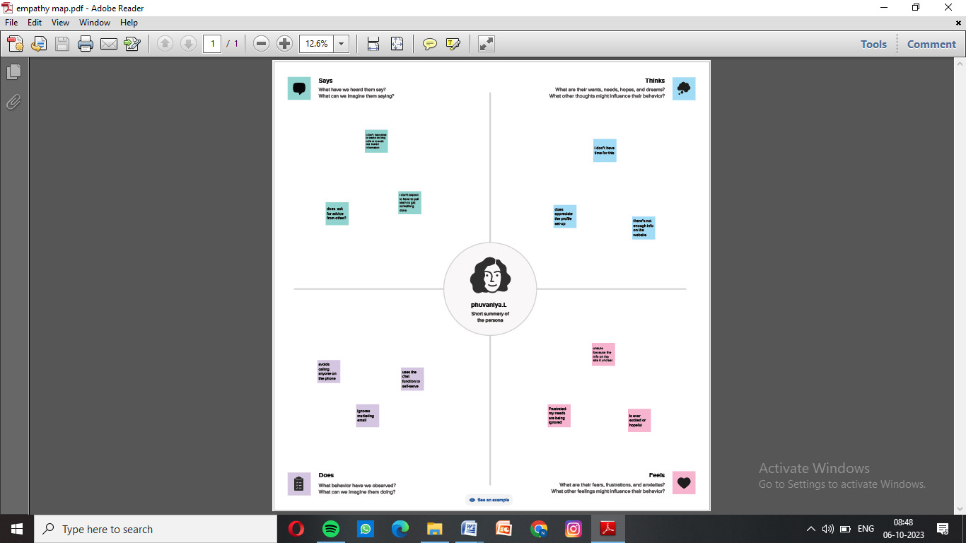

***IDEATION & BRAINSTORMING MAP :***

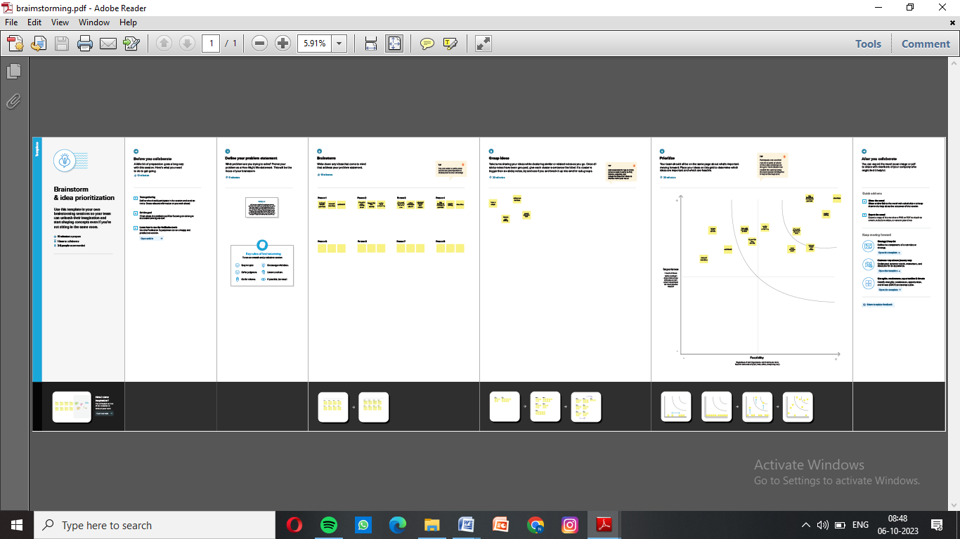

**RESULT:**

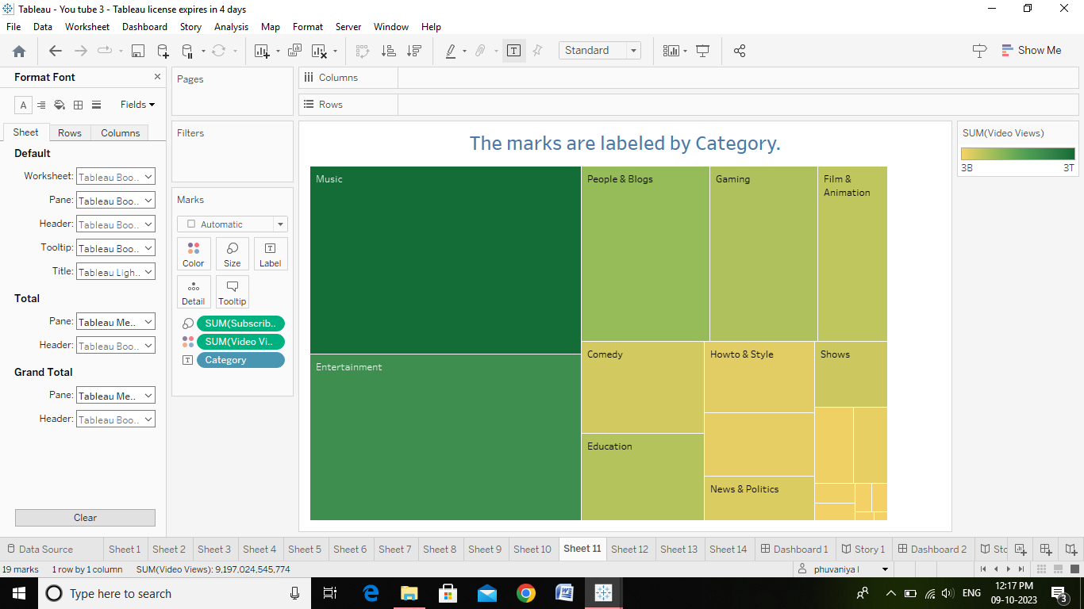

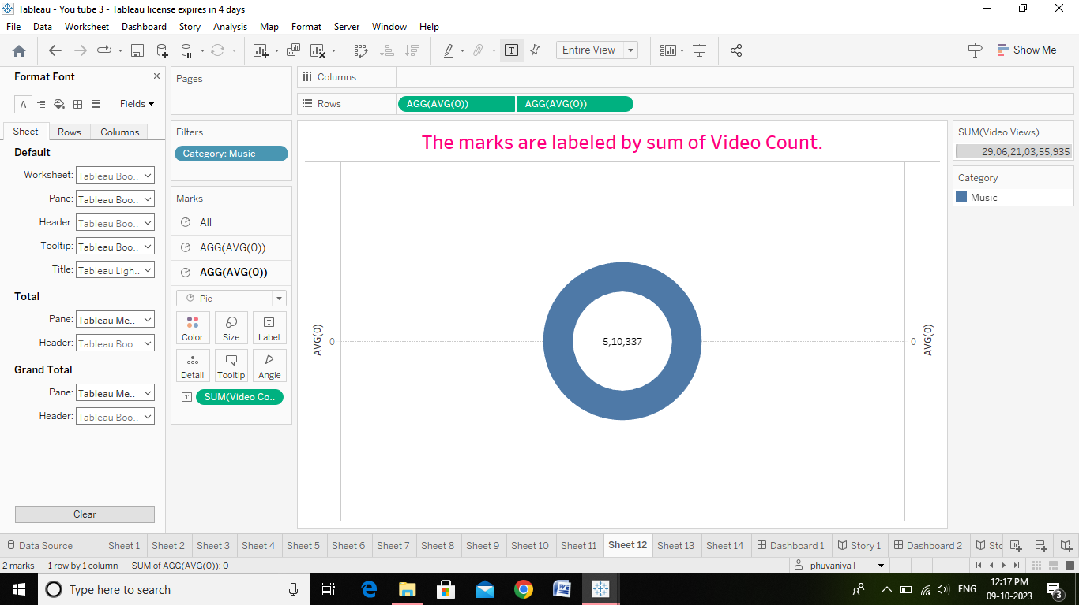

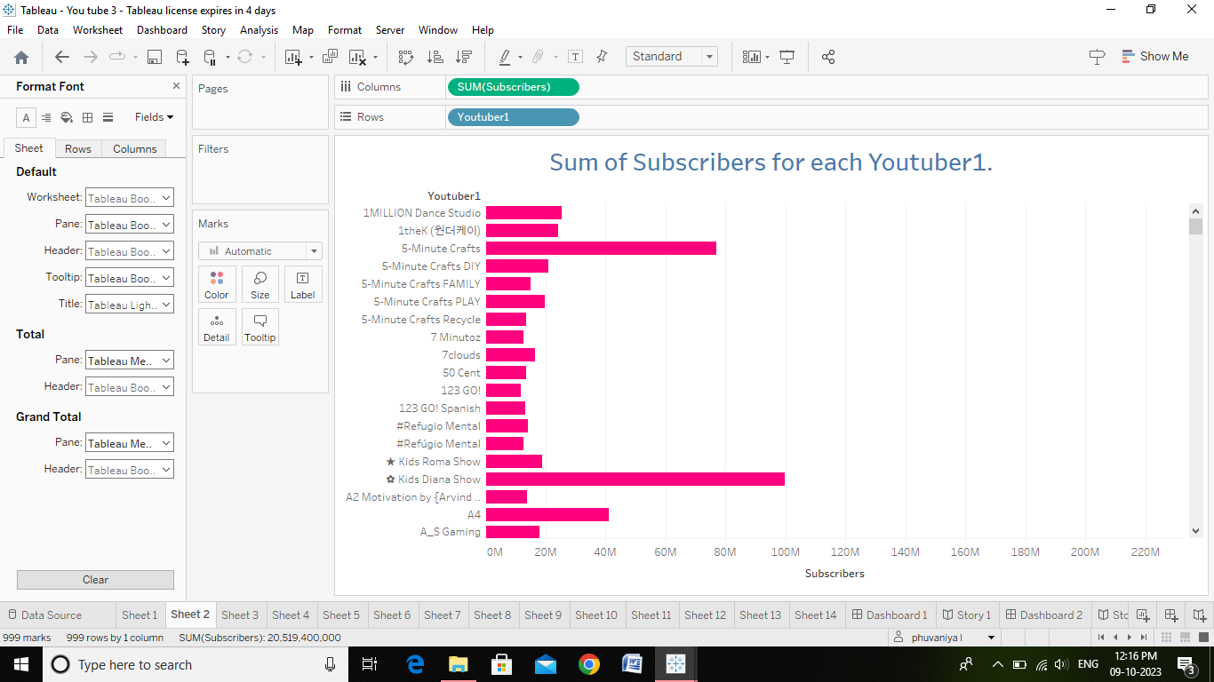

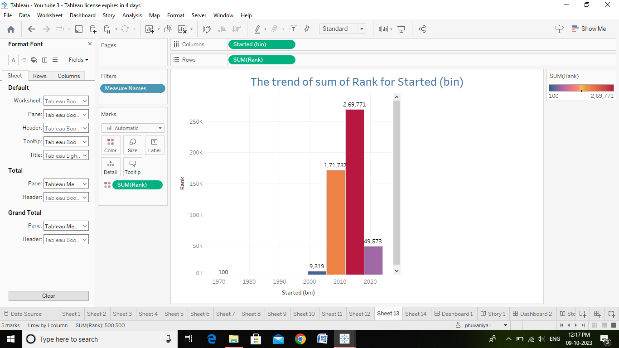

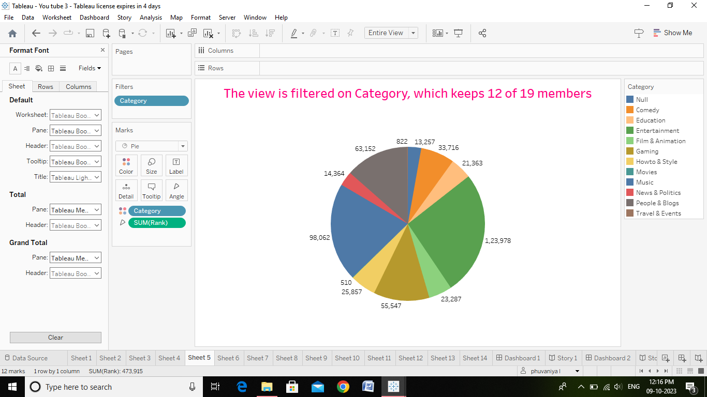

**DASHBOARD:**

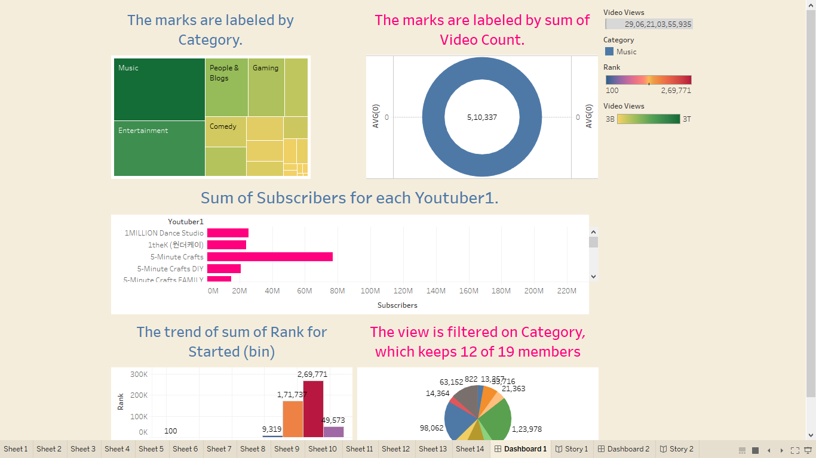

**STORY:**

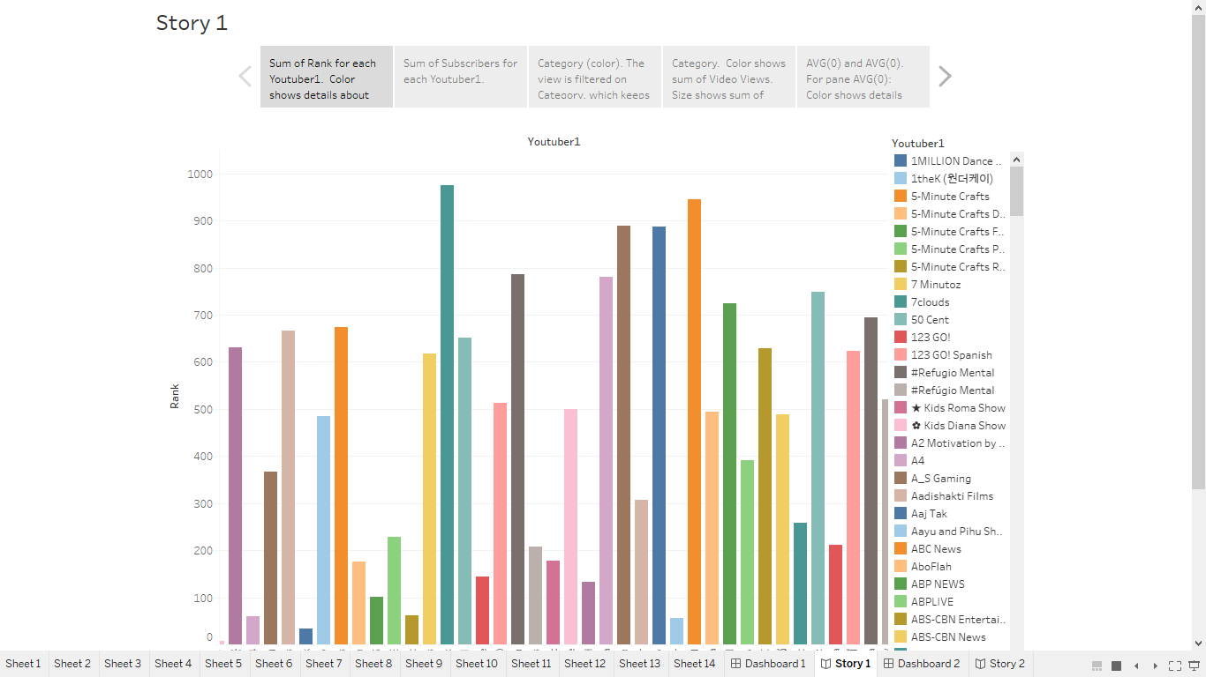

**ADVANTAGES AND DISADVANTAGES OF YOUTUBE**:

***ADVANTAGES:***

* 1. **~~YOUTUBE~~** as an information dissemination platform for students.
  2. It’s tha perfect place to learn and gain expertise.
  3. ***~~YOUTUBE’S~~*** user-friendliness.
  4. **~~YOUTUBE~~** for brand promation.
  5. Easy Earning is at the very top of the list of **~~YOUTUBE~~** benefits for vloggers.
  6. Ads-a drawback of youtube for the audience.

***DISADVANTAGES:***

* 1. Ads- a drawback of youtube for the audience. **ADVERTISEMENT**.
  2. A lot of distraction. **ADVERTISEMENT**.

**APPLICATIONS:**

1. Audio/video file upload.
2. Live Captioning.
3. Reporting/Analytics.
4. Social Sharing.
5. Speech Recognition.
6. Subtitles/Closed Captions.
7. Text Overlay.
8. Time Stamps.

**CONCLUSION:**

In conclusion, YouTube is a very strong growing platform creating lots of opportunities for entrepreneurs and motivated people.

**FUTURE SCOPE:**

Overall, it's challenging to predict precisely what the future holds for YouTube.

Still, it's likely that the platform will continue to evolve and adapt to changing user needs and technological developments, making it a central player in the online video space for years to come.